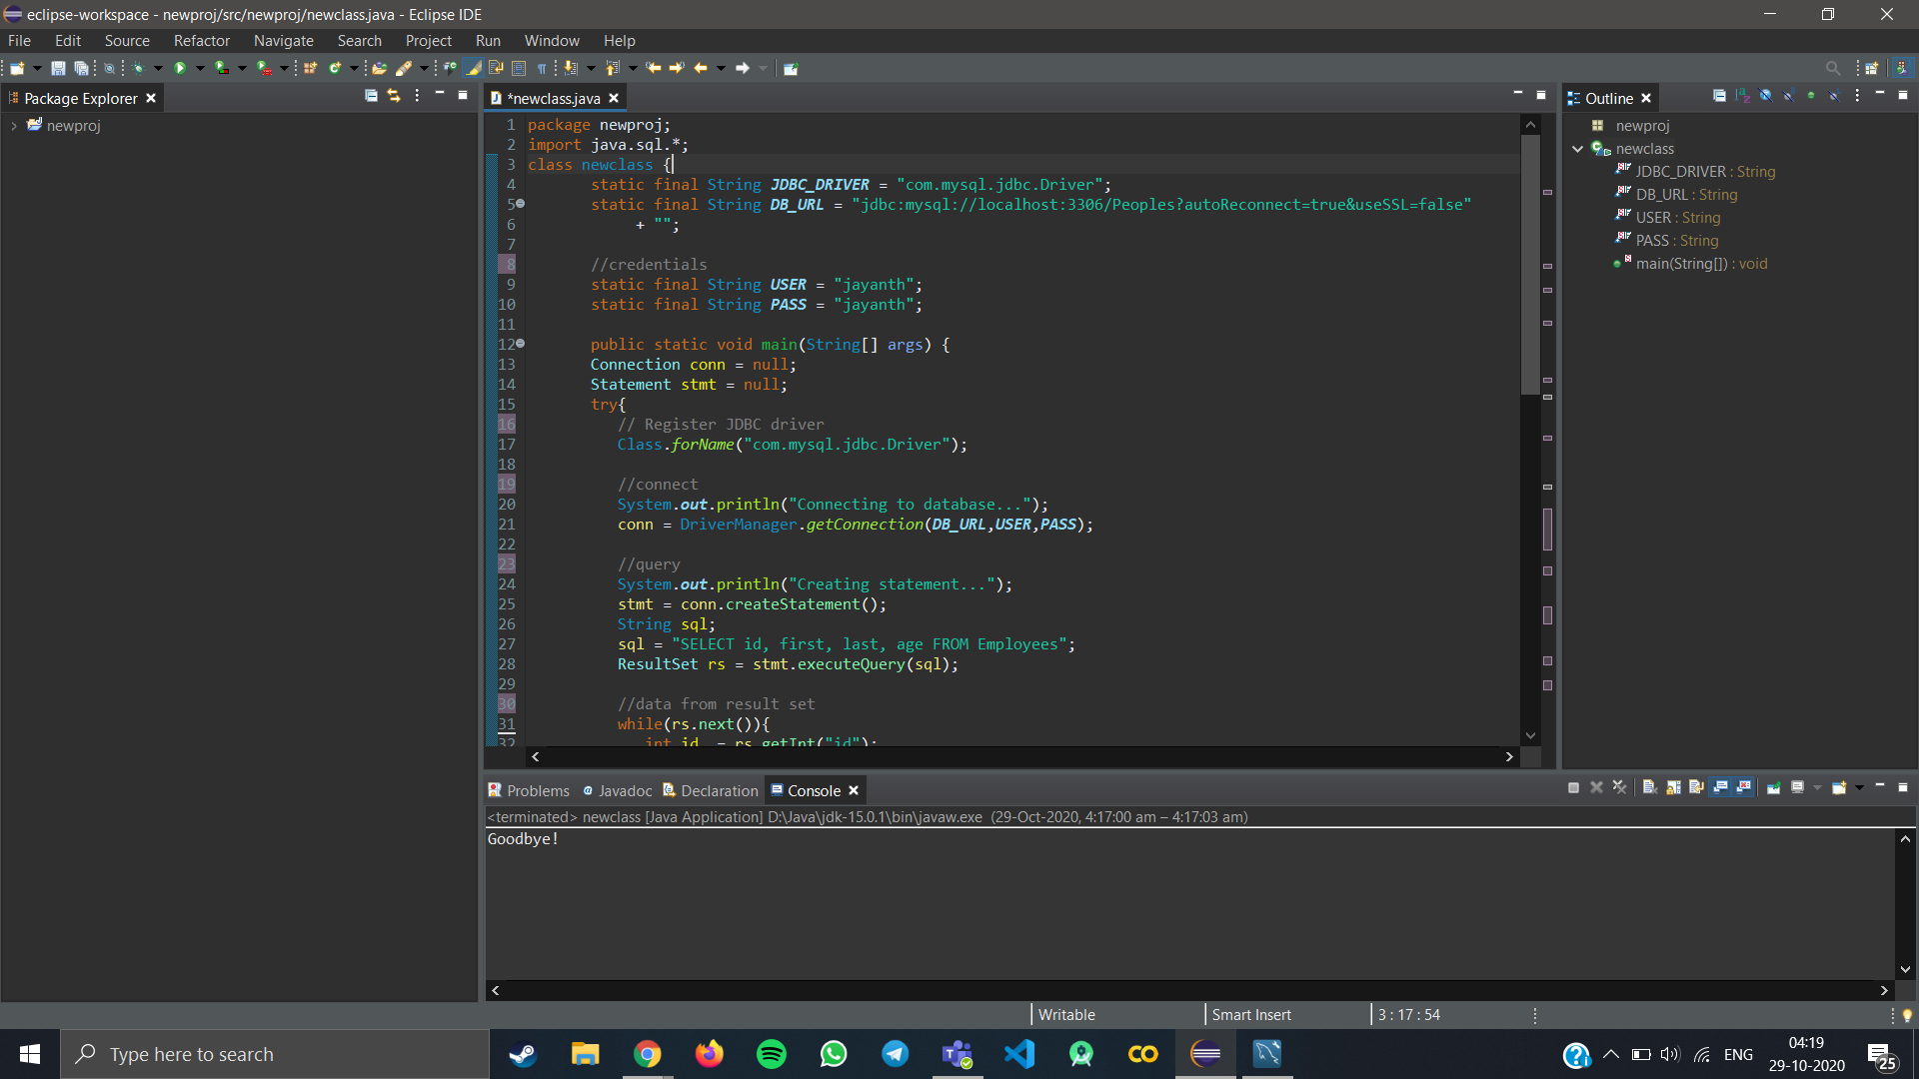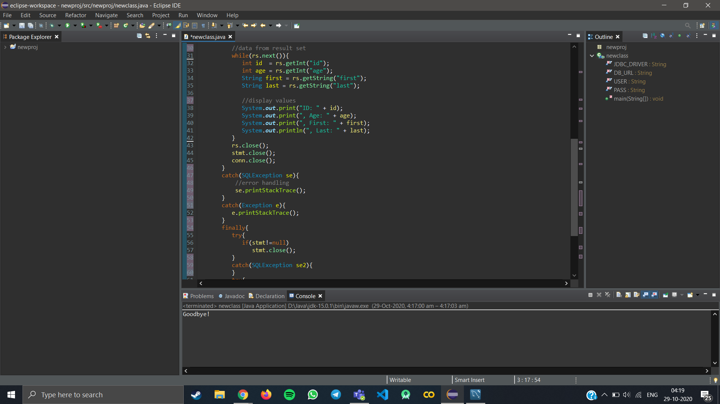

CODE :

package newproj;

import java.sql.*;

class newclass {

static final String JDBC_DRIVER = "com.mysql.jdbc.Driver";

static final String DB_URL = "jdbc:mysql://localhost:3306/Peoples?autoReconnect=true&useSSL=false"

+ "";

//credentials

static final String USER = "jayanth";

static final String PASS = "jayanth";

public static void main(String[] args) {

Connection conn = null;

Statement stmt = null;

try{

// Register JDBC driver

Class.forName("com.mysql.jdbc.Driver");

//connect

System.out.println("Connecting to database...");

conn = DriverManager.getConnection(DB_URL,USER,PASS);

//query

System.out.println("Creating statement...");

stmt = conn.createStatement();

String sql;

sql = "SELECT id, first, last, age FROM Employees";

ResultSet rs = stmt.executeQuery(sql);

//data from result set

while(rs.next()){

int id = rs.getInt("id");

int age = rs.getInt("age");

String first = rs.getString("first");

String last = rs.getString("last");

//display values

System.out.print("ID: " + id);

System.out.print(", Age: " + age);

System.out.print(", First: " + first);

System.out.println(", Last: " + last);

}

rs.close();

stmt.close();

conn.close();

}

catch(SQLException se){

//error handling

se.printStackTrace();

}

catch(Exception e){

e.printStackTrace();

}

finally{

try{

if(stmt!=null)

stmt.close();

}

catch(SQLException se2){

}

try{

if(conn!=null)

conn.close();

}

catch(SQLException se){

se.printStackTrace();

}

}//total three tries

System.out.println("Goodbye!");}

}